Review: Rappahannock County is Brilliantly Done
Thursday, 14 April 2011 15:54 |
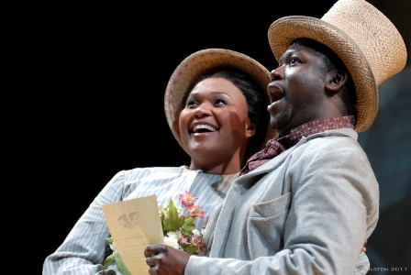
Soprano Aundi Marie Moore and baritone Kevin Moreno may have portrayed penny-less slaves on stage, but they clearly owned the hearts of those in the audience Tuesday night at the Harrison Opera House with million dollar performances.
The Virginia Arts Festival kicked-off its 15th season in fine form with a sold-out world premiere of Rappahannock County, a musical theatre work co-commissioned by the Arts Festival, Virginia Opera and two additional arts organizations. The piece is an artistic compliment to the 150th anniversary of the American Civil War. It chronologically touches on Secession, journeys through the four dark periods of winter and concludes with a contrasting view of dismayed Southerners and cautiously jubilant former slaves on their wedding day.
Rappahannock County was most impressive for its multi-media visual component. The 17-piece chamber orchestra was comprised of Virginia Symphony Orchestra members. They were delicately illuminated behind a semi-transparent screen which served as the backdrop. The impression of a three-ridged mountain scene of the Blue Ridge was a constant on the screen as historic illustrations, paintings and photographs from the Civil War were magically projected as topical accompaniments. The scenery and projection design of Wendall Harrington made for an absolutely brilliant production bordering on documentarian.
Rappahannock County is more of a contemporary opera than Broadway-style musical in that it tells its story exclusively through songs – 23 in all – performed consecutively in five parts and enhanced with the visuals on the screen. Five actor/singers play the roles of various characters, with the war mainly in the background. Totaling 87 minutes in length, it’s highly entertaining and assessable to those with even a minimal interest in live theater.
Mood and emotion run the gamut throughout the work and are dynamically paired by Gordon and Campbell. The lyrical content is honest and true to the times, though with hints of contemporary viewpoint. The opening “Sanctified by God,” sung by the ever-present baritone Mark Walters, and “A Noble Institution,” by smooth tenor Matthew Tuell, may make some viewers uneasy with its gleeful justification for slavery, though some in the audience snickered undoubtedly through modern ears of such an absurdity. Two sides are generally given from a Southern view of the Civil War’s origin and “States Rights” touched on that, however, music and lyrical interplay cast some shadow on this notion.
In listening for that memorable aria that an opera should possess or “hit song” a Broadway musical such as Annie and Oklahoma delivers, the Gordon/Campbell team scored high on “All I Ever Known” and “Hallie-Ann,” both sung by Aundi Marie Moore, as well as “For Love of Country” where Walters powerfully bellows the forgotten soldier John Smith.
Where baritone Kevin Moreno often delivered comical relief as a slave (“Bound to Be”/”Being Small”), he also gave the most impassioned performance of the night as a union soldier struggling within himself as he chose not to killed a pleading Confederate (“I Walk Away”).
Music composer Ricky Ian Gordon, considered a hot talent in the musical theater world, and lyricist Mark Campbell proved to be outstanding collaborators for what is likely to be considered one of the best musical theater works of 2011.

